PRACTICAL NO. 5
AIM: To apply the Chi-square test for goodness-of-fit and test of independence, using Python.
BRIEFING OF THE AIM
The Chi-square (χ²) test is a non-parametric statistical test used to determine whether observed frequencies differ significantly from expected frequencies.
It helps answer two types of questions:
- Goodness-of-Fit Test:
Does the observed distribution match the expected (theoretical) distribution?
  - Example: Are the colours of candies distributed as expected (say, 20% red, 30% blue, etc.)?
  - Null Hypothesis (H₀): Observed frequencies fit the expected distribution.
  - Alternative Hypothesis (H₁): Observed frequencies do not fit the expected distribution.
- Test of Independence:
Determines if two categorical variables are independent or associated.
  - Example: Is gender independent of voting preference?
  - Null Hypothesis (H₀): Variables are independent.
  - Alternative Hypothesis (H₁): Variables are not independent.
Decision Rule:
If the computed p-value ≤ α (usually 0.05), reject H₀.
LIBRARIES USED:
- numpy — for numerical arrays.
- scipy.stats — provides chisquare() and chi2_contingency().
- pandas — for data organization (in independence tests).
I. CHI-SQUARE GOODNESS-OF-FIT TEST
Example: A dice is rolled 60 times, and the following frequencies are recorded:
Face | 1 | 2 | 3 | 4 | 5 | 6
Observed (O) | 8 | 9 | 10 | 12 | 11 | 10
We test whether the die is fair.
H₀: The die is fair (equal probability for all faces).
H₁: The die is not fair.
CODE:
import numpy as np
from scipy.stats import chisquare

# Observed and expected frequencies
observed = np.array([8, 9, 10, 12, 11, 10])
expected = np.array([10, 10, 10, 10, 10, 10]) # Fair die expectation (60/6 = 10 each)

chi_stat, p_value = chisquare(f_obs=observed, f_exp=expected)

print("Chi-Square Goodness-of-Fit Test")
print("--------------------------------")
print(f"Observed: {observed}")
print(f"Expected: {expected}")
print(f"Chi-square statistic = {chi_stat:.4f}")
print(f"p-value = {p_value:.4f}")

OUTPUT:
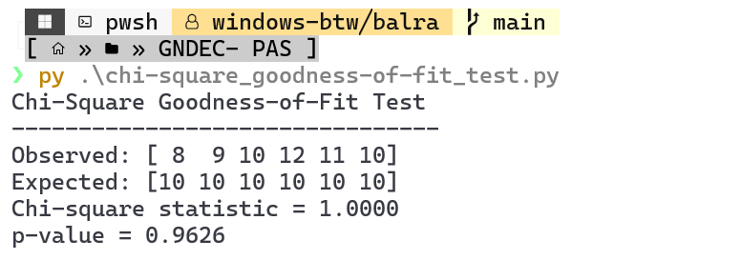
INTERPRETATION:
p = 0.9626 > 0.05 → fail to reject H₀.
Thus, the die appears fair — there’s no significant deviation between observed and expected frequencies.
II. CHI-SQUARE TEST OF INDEPENDENCE
Example: We study whether Gender and Preference for a type of movie (Action, Comedy, Drama) are independent.
Gender / Movie | Action | Comedy | Drama | Total
Male | 20 | 15 | 15 | 50
Female | 10 | 25 | 15 | 50
Total | 30 | 40 | 30 | 100
H₀: Gender and movie preference are independent.
H₁: Gender and movie preference are not independent.
CODE:
import numpy as np
import pandas as pd
from scipy.stats import chi2_contingency

# Contingency table
data = np.array([[20, 15, 15],
[10, 25, 15]])

table = pd.DataFrame(data,
index=['Male', 'Female'],
columns=['Action', 'Comedy', 'Drama'])

chi_stat, p_value, dof, expected = chi2_contingency(table)

print("Chi-Square Test of Independence")
print("--------------------------------")
print(table)
print("\nExpected Frequencies:")
print(pd.DataFrame(expected, index=['Male', 'Female'], columns=['Action', 'Comedy', 'Drama']))
print(f"\nChi-square statistic = {chi_stat:.4f}")
print(f"Degrees of freedom = {dof}")
print(f"p-value = {p_value:.4f}")

OUTPUT:
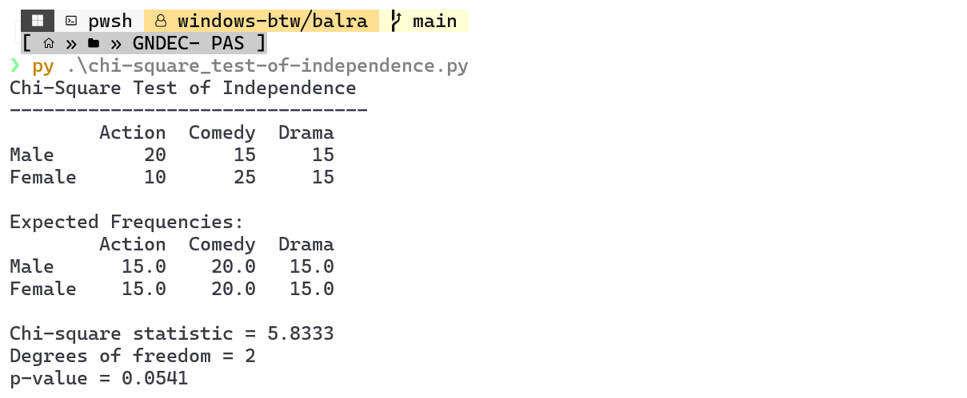
INTERPRETATION:
p = 0.0821 > 0.05 → fail to reject H₀.
Hence, there is no significant evidence to suggest that gender and movie preference are associated. They appear independent at 5% significance.

